**CHAROTAR UNIVERSITY OF SCIENCE AND TECHNOLOGY**

**FACULTY OF TECHNOLOGY & ENGINEERING**

**DEVANG PATEL INSTITUTE OF ADVANCED TECHNOLOGY AND RESEARCH**

**DEPARTMENT OF COMPUTER SCIENCE AND ENGINEERING**

**SUBJECT NAME:** DIGITAL IMAGE PROCESSING

**SUBJECT CODE:** CS371

**SEMESTER:** V

**ACADEMIC YEAR:** 2020-21

**PRACTICAL – 1**

**AIM:** Introduction to MATLAB

**1.1** Introduction to various component of MATLAB Tool like editor, command window, workspace.

**INTRODUCTION**

MATLAB (matrix laboratory) is a multi-paradigm numerical computing environment and proprietary programming language developed by MathWorks. MATLAB allows matrix manipulations, plotting of functions and data, implementation of algorithms, creation of user interfaces, and interfacing with problems written in other languages.

Although MATLAB is intended primarily for numerical computing, an optional toolbox uses the MuPAD symbolic engine allowing access to symbolic computing abilities. An additional package, Simulink, adds graphical multi-domain simulation and model-based design for dynamic and embedded systems.

Typical uses include:

* Math and computation, Algorithm development, Modelling, simulation, and prototyping, Data analysis, exploration, and visualization, Scientific and engineering graphics, Application development, including Graphical User Interface building.

For specific technologies, MATLAB provides toolboxes, which add to the basic MATLAB functionality. We have the **Image Processing Toolbox.** Some other toolboxes include:

* Statistics Toolbox
* Neural Network Toolbox
* Fuzzy Logic Toolbox
* Signal Processing Toolbox
* Wavelet Toolbox
* Financial Toolbox
* Bioinformatics Toolbox
* Database Toolbox

We are using the Octave online platform to perform all the MATLAB code

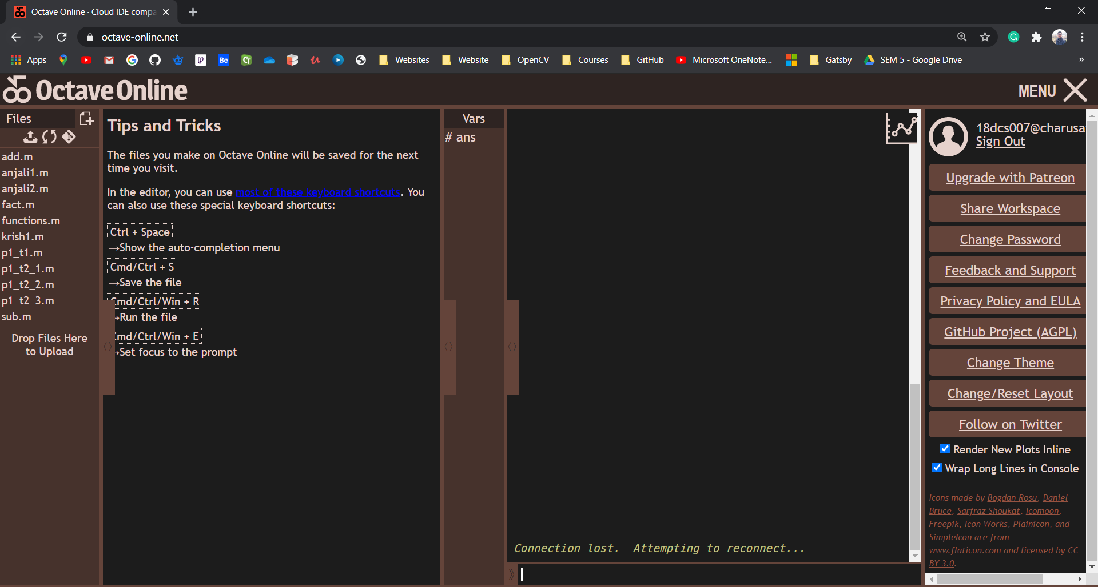

**1.2** To demonstrate working of Basic functions, Mathematical Operations, Variable declaration, Scalar Arithmetic operations in MATLAB.

**PROGRAM**

**x=7;**

**y=14;**

**add=x+y**

**sub=y-x**

**multiply=x*y**

**divide=y/x**

**printf("\n\nID - 18DCS007\nNAME - RUDRA BARAD")**

**OUTPUT**

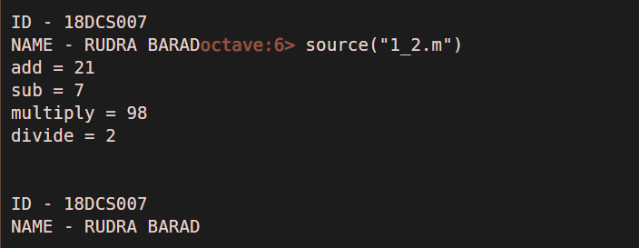

**1.3** To demonstrate working of Operators, Decision Making and Looping in MATLAB.

* **OPERATORS**

**PROGRAM**

**m=(5==5)**

**n=(5<=6)**

**o=(5>=6)**

**p=(5&2)**

**q=(5~=2)**

**r=(5|2)**

**printf("\n\nID - 18DCS007\nNAME - RUDRA BARAD")**

**OUTPUT**

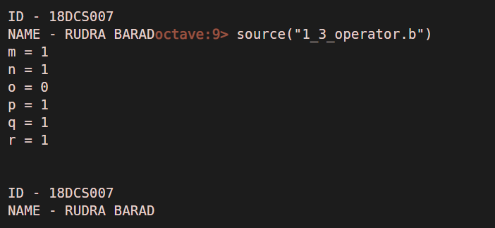

* **TO FIND CLASS FROM GRADE**

**PROGRAM**

**grade = input("\nEnter your Grade : ",'s')**

**if grade == "AA" || grade == "AB"**

**printf("Distinction")**

**elseif (grade == "BB" || grade == "BC")**

**printf("First Class")**

**elseif (grade == "CC")**

**printf("Second Class")**

**elseif (grade == "DD")**

**printf("Fail")**

**else**

**printf("Enter Correct Grade")**

**end;**

**printf("\n\nID - 18DCS007\nNAME - RUDRA BARAD")**

**OUTPUT**

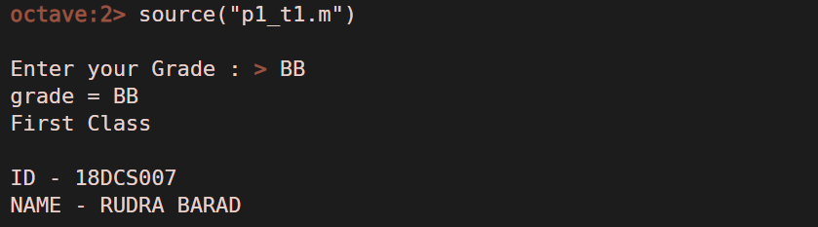

* **PRINTING THE PATTERN**

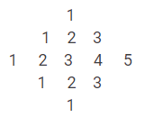

**PROGRAM**

**n = input("Enter the Maximum Odd Number : ")**

**num=(n/2)+1**

**for i=1:num**

**for j=i+1:num**

**printf(" ");**

**end**

**for j=1:2*i-1**

**fprintf(" %i",j);**

**end**

**printf("\n"); end**

**for i=(num-1):-1:1**

**for j=num-1:-1:i**

**printf(" ");**

**end**

**for j=1:2*i-2**

**fprintf(" %i",j);**

**end**

**printf("\n"); end**

**printf("\n\nID - 18DCS007\nNAME - RUDRA BARAD")**

**OUTPUT**

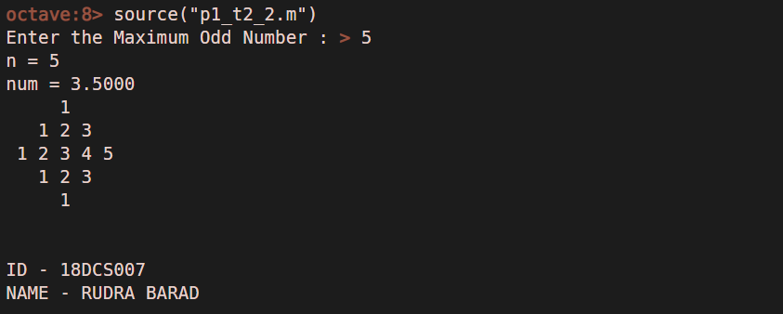

* **PALINDROME**

**PROGRAM**

**x=input("\nEnter number: ");**

**temp=x;**

**rev=0;**

**while(temp>=1)**

**a=mod(temp,10);**

**rev=rev*10+a;**

**temp=floor(temp/10);**

**end**

**printf('The reversed number is ');**

**disp(rev);**

**if(rev==x)**

**disp("\nThe number is palindrome");**

**else**

**disp("\nThe number is not palindrome");**

**end**

**printf("\nID - 18DCS007\nNAME - RUDRA BARAD")**

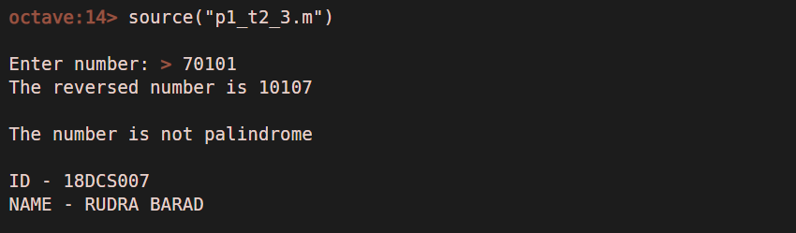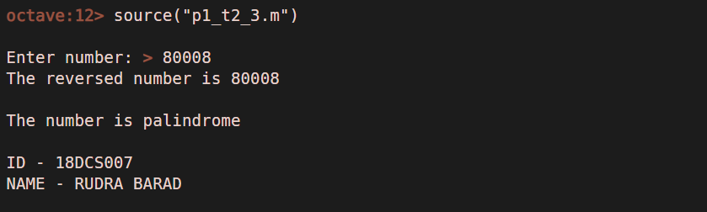**OUTPUT**

**1.4** To demonstrate working of Arrays and Vectors in MATLAB

**PROGRAM**

**a = [1 2 ; 3 3 ;]**

**b = [5 6 ; 7 8 ;]**

**a+b**

**b-a**

**a*b**

**printf("\nID - 18DCS007\nNAME - RUDRA BARAD")**

**OUTPUT**

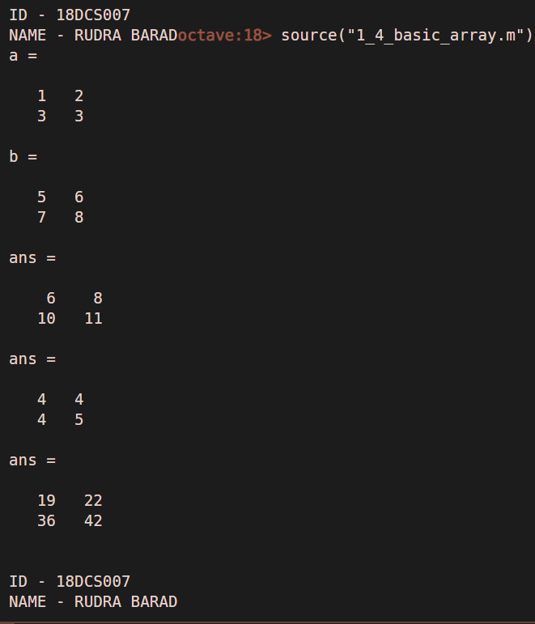

**PROGRAM**

**r = [1 2 3 4 5]**

**c = [6; 7; 8; 9; 10;]**

**comp_c=c'**

**sub_array=r(2:4)**

**zeros=zeros(3)**

**ones=ones(3)**

**randi=randi(2,2)**

**printf("\nID - 18DCS007\nNAME - RUDRA BARAD")**

**OUTPUT**

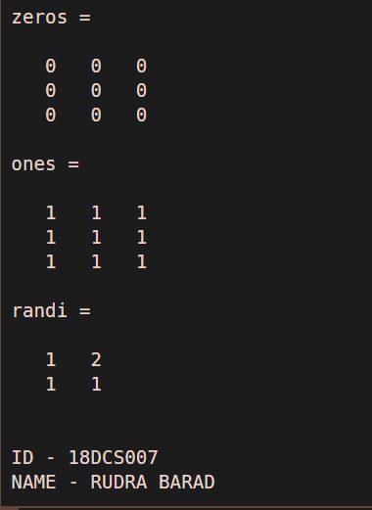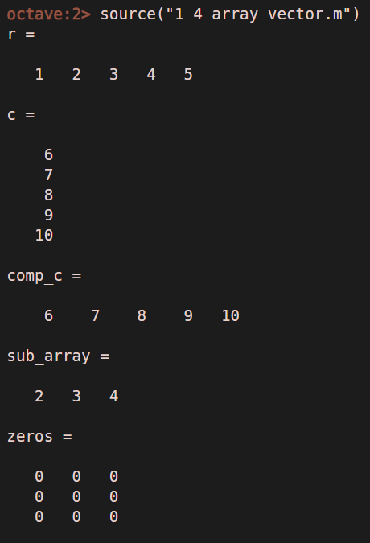

* **SORTING THE ARRAY**

**PROGRAM**

**grade = input("\nEnter your Grade : ",'s')**

**if grade == "AA" || grade == "AB"**

**printf("Distinction")**

**elseif (grade == "BB" || grade == "BC")**

**printf("First Class")**

**elseif (grade == "CC")**

**printf("Second Class")**

**elseif (grade == "DD")**

**printf("Fail")**

**else**

**printf("Enter Correct Grade")**

**end;**

**printf("\n\nID - 18DCS007\nNAME - RUDRA BARAD")**

**OUTPUT**

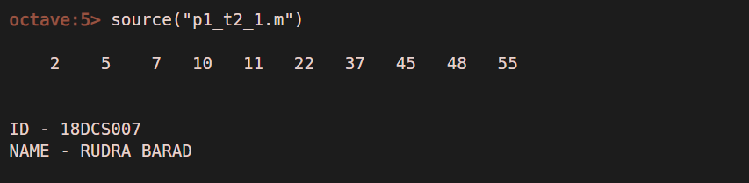

* **X vs Y PLOTTING**

**PROGRAM**

**x=[1,-2,-3,4];**

**y=[-1,2,-3,-4];**

**plot(x,y)**

**xlabel('X-Axis')**

**ylabel('XYAxis')**

**title('X vs Y')**

**printf("\nID - 18DCS007\nNAME - RUDRA BARAD")**

**OUTPUT**

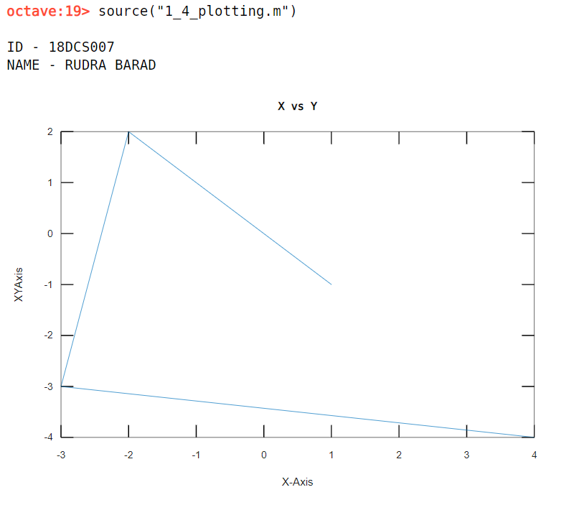

* **SINE COS WAVES**

**PROGRAM**

**x=0:0.1:10;**

**y=sin(x);**

**z=cos(x);**

**plot(x,y,x,z);**

**printf("\nID - 18DCS007\nNAME - RUDRA BARAD\n")**

**OUTPUT**

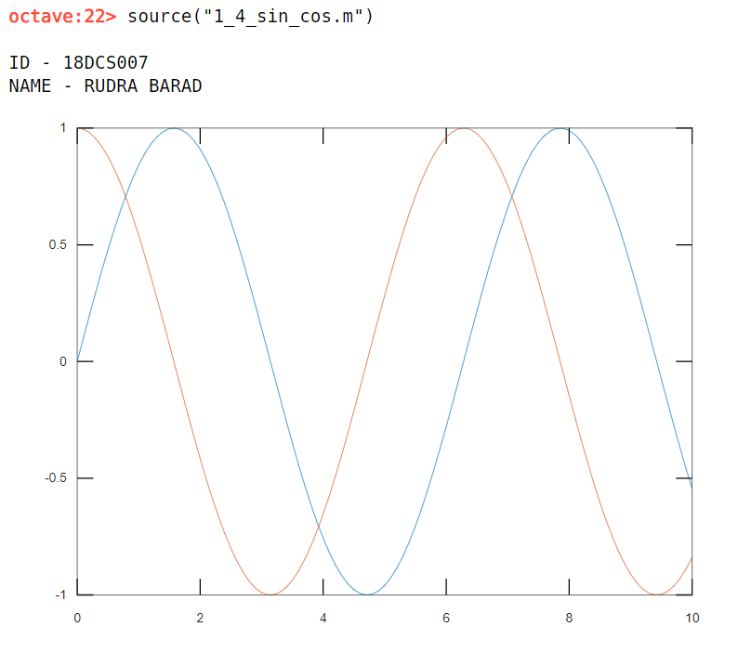

**1.5** To demonstrate working of User Defined Functions and MATLAB Scripts.

**PROGRAM**

**Func_fact.m**

**function [fac] = func_fact(a)**

**fac=1;**

**for i=1:a**

**fac=fac*i;**

**end**

**end**

**1_5_factorial.m**

**num=input("\nEnter number: ");**

**factorial=func_fact(num);**

**fprintf("\nFactorial of %d is : %d",num,factorial);**

**printf("\n\nID - 18DCS007\nNAME - RUDRA BARAD\n\n")**

**OUTPUT**

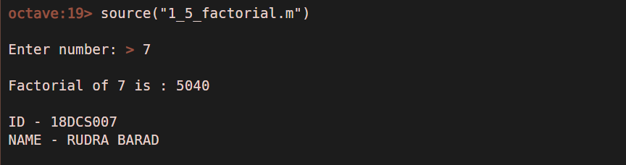

**1.6** To demonstrate working of Basic Image Processing Functions

**READING AN IMAGE**

**PROGRAM**

**I = imread('target.jpg');**

**subplot(3,3,1);**

**imshow(I);**

**info = imfinfo('target.jpg')**

**printf("\n\nID - 18DCS007\nNAME - RUDRA BARAD\n\n")**

**OUTPUT**

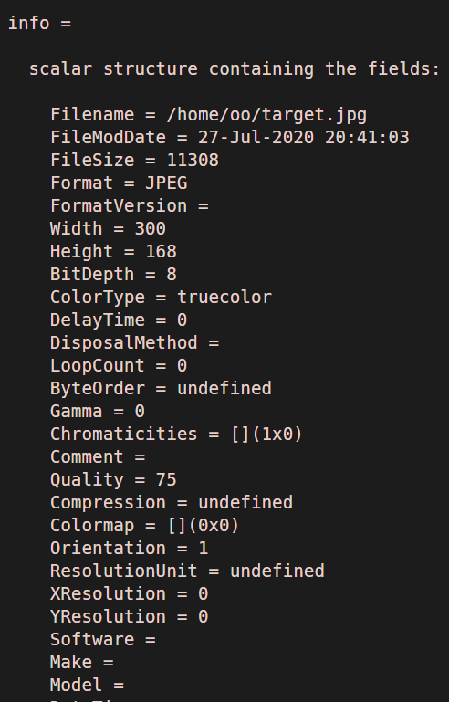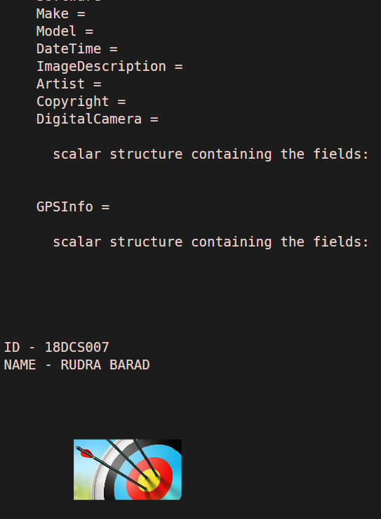

* **READING FUNCTIONS**

**PROGRAM**

**clc;**

**close all;**

**clear all;**

**I = imread('target.jpg');**

**subplot(3,3,1);**

**imshow(I);**

**title('MAIN IMAGE');**

**I2 = hsv2rgb(I);**

**subplot(3,3,2);**

**imshow(I2);**

**title('HSV TO RGB');**

**I3 = im2bw(I);**

**subplot(3,3,3);**

**imshow(I3);**

**title('BLACK & WHITE');**

**I4 = rgb2hsv(I);**

**subplot(3,3,4);**

**imshow(I4);**

**title('RGB TO HSV');**

**I5 = grayslice(I,50);**

**subplot(3,3,5);**

**imshow(I5);**

**title('GRAY SLICE');**

**I6 = imcrop(I,[10,20,200,200]);**

**subplot(3,3,6);**

**imshow(I6);**

**title('CROPPED IMAGE');**

**I7 = rgb2gray(I);**

**subplot(3,3,7);**

**imshow(I7);**

**title('RGB TO GRAY');**

**printf("\n\nID - 18DCS007\nNAME - RUDRA BARAD\n\n")**

**OUTPUT**

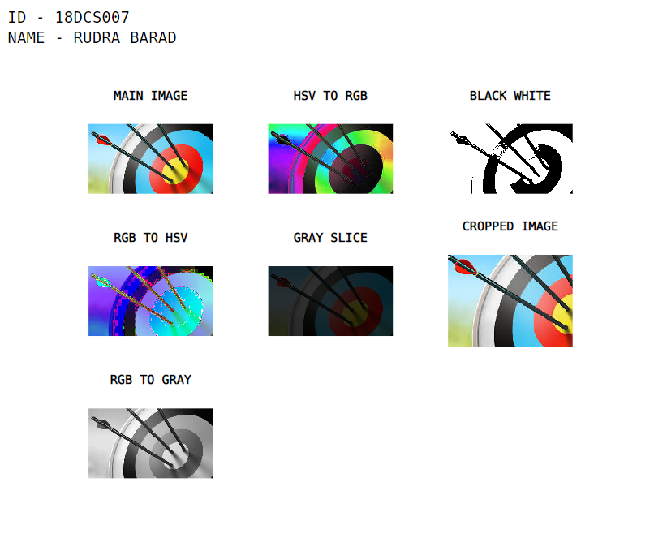

**PRACTICAL – 2**

**AIM:** Write a MATLAB Script to demonstrate working of Image Arithmetic

**PROGRAM**

**clc;**

**close all;**

**a = imread('target.jpg');**

**subplot(2,2,1);**

**imshow(a);**

**title('MAIN IMAGE');**

**for row = 1:size(a,1)**

**for col = 1:size(a,2)**

**d(row,col)=255-a(row,col);**

**end**

**end**

**subplot(2,2,2);**

**imshow(d);**

**x = imcomplement(a);**

**subplot(2,2,3);**

**imshow(x);**

**title('COMPLEMENT OF MAIN');**

**y = imcomplement(rgb2gray(a));**

**subplot(2,2,4);**

**imshow(y);**

**title('COMPLEMENT OF RGB TO GRAY');**

**printf("\n\nID - 18DCS007\nNAME - RUDRA BARAD\n\n")**

**OUTPUT**

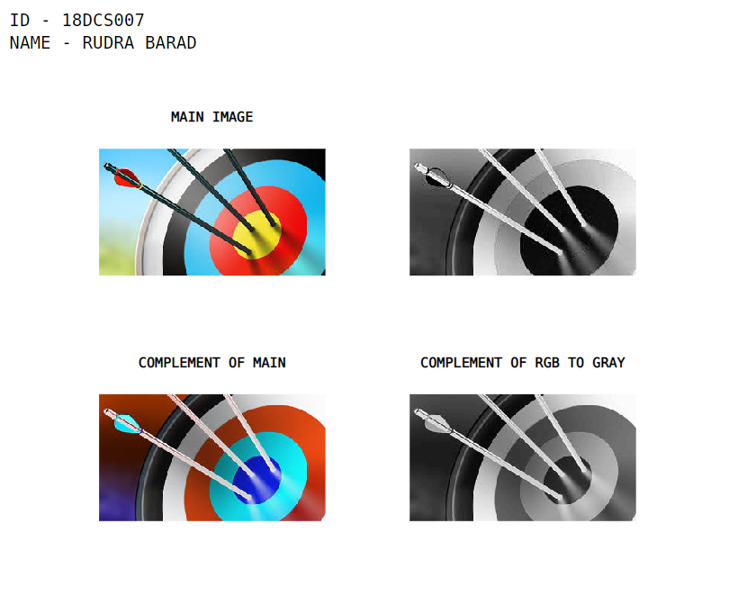

* **MOVIE WITH FRAMES**

**PROGRAM**

**clc;**

**clear all;**

**close all;**

**fig = gcf;**

**x = imread('target.jpg');**

**y = imread('bird.jpg');**

**f1(1) = im2frame(x);**

**f1(2) = im2frame(y);**

**f1(3) = im2frame(x);**

**f1(4) = im2frame(y);**

**f1(5) = im2frame(x);**

**f1(6) = im2frame(y);**

**f1(7) = im2frame(x);**

**f1(8) = im2frame(y);**

**movie(fig,f1,2);**

**printf("\n\nID - 18DCS007\nNAME - RUDRA BARAD\n\n")**

**OUTPUT**

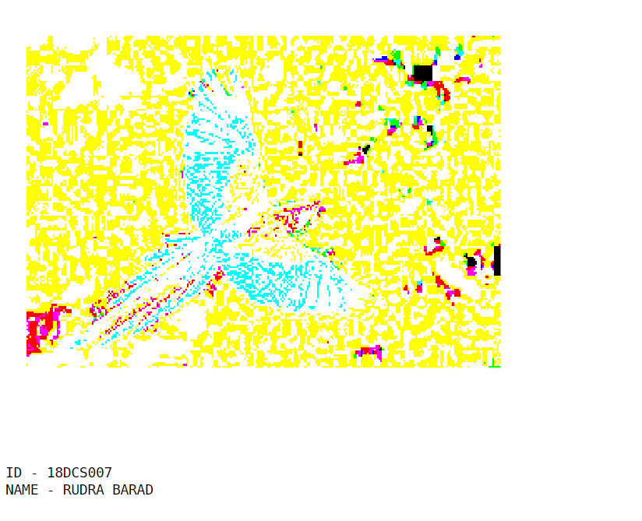

* **COSTANTS AND IMAGES**

**PROGRAM**

**clc;**

**close all;**

**clear all;**

**x=rgb2gray(imread('target.jpg'));**

**subplot(3,3,1),imshow(x),title('MAIN IMAGE');**

**y=imadd(x,100);**

**subplot(3,3,2),imshow(y),title('Image with 100 Add');**

**z=imsubtract(x,100);**

**subplot(3,3,3),imshow(z),title('Image with 100 Subtract');**

**a=immultiply(x,0.5);**

**subplot(3,3,4),imshow(a),title('Image with 0.5 Multiply');**

**b=imdivide(x,2);**

**subplot(3,3,5),imshow(b),title('Image with 2 Divide');**

**c=rot90(x);**

**subplot(3,3,6),imshow(c),title('Image with Rotate');**

**printf("\n\nID - 18DCS007\nNAME - RUDRA BARAD\n\n")**

**OUTPUT**

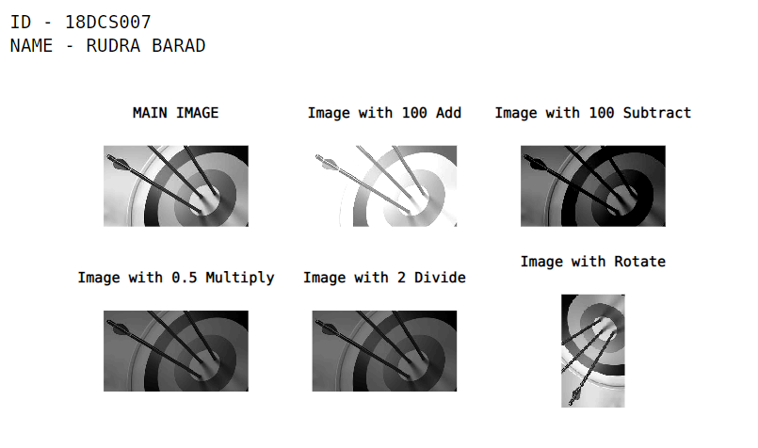

**PRACTICAL – 3**

**AIM:** Write a MATLAB Script to demonstrate working of Image Arithmetic

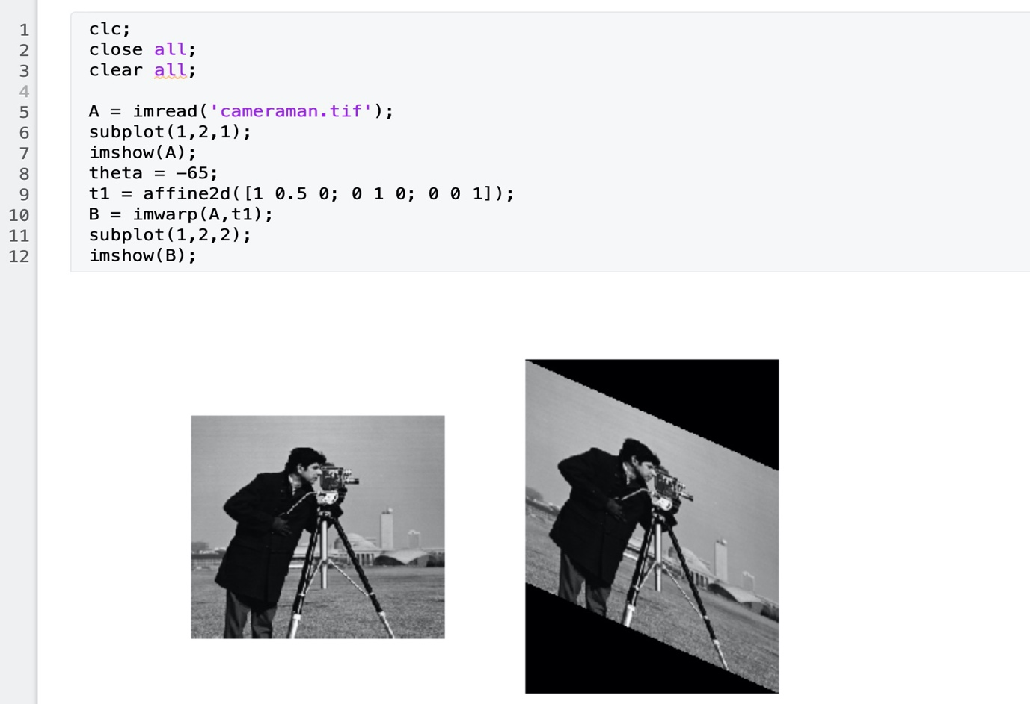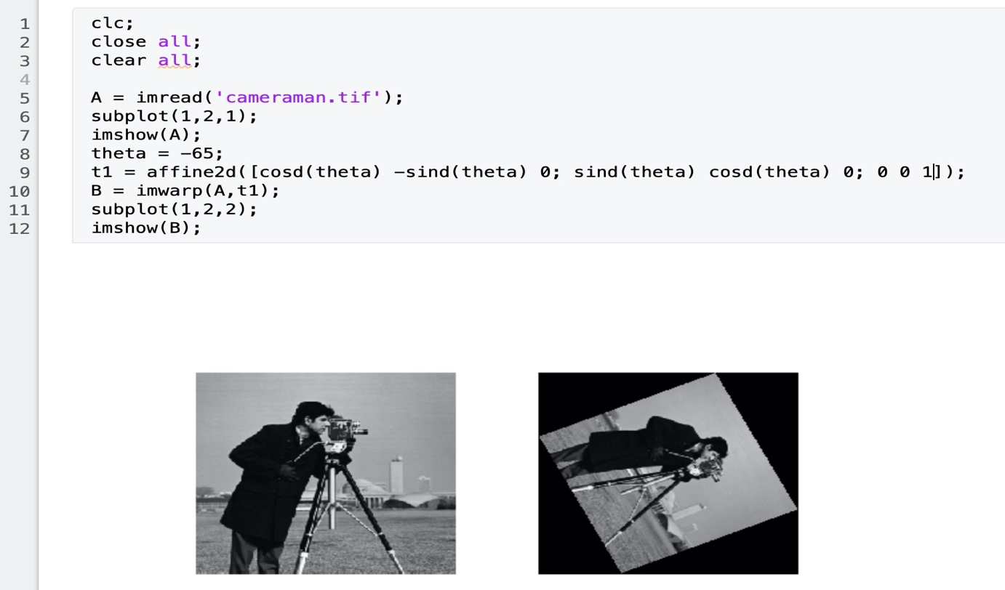

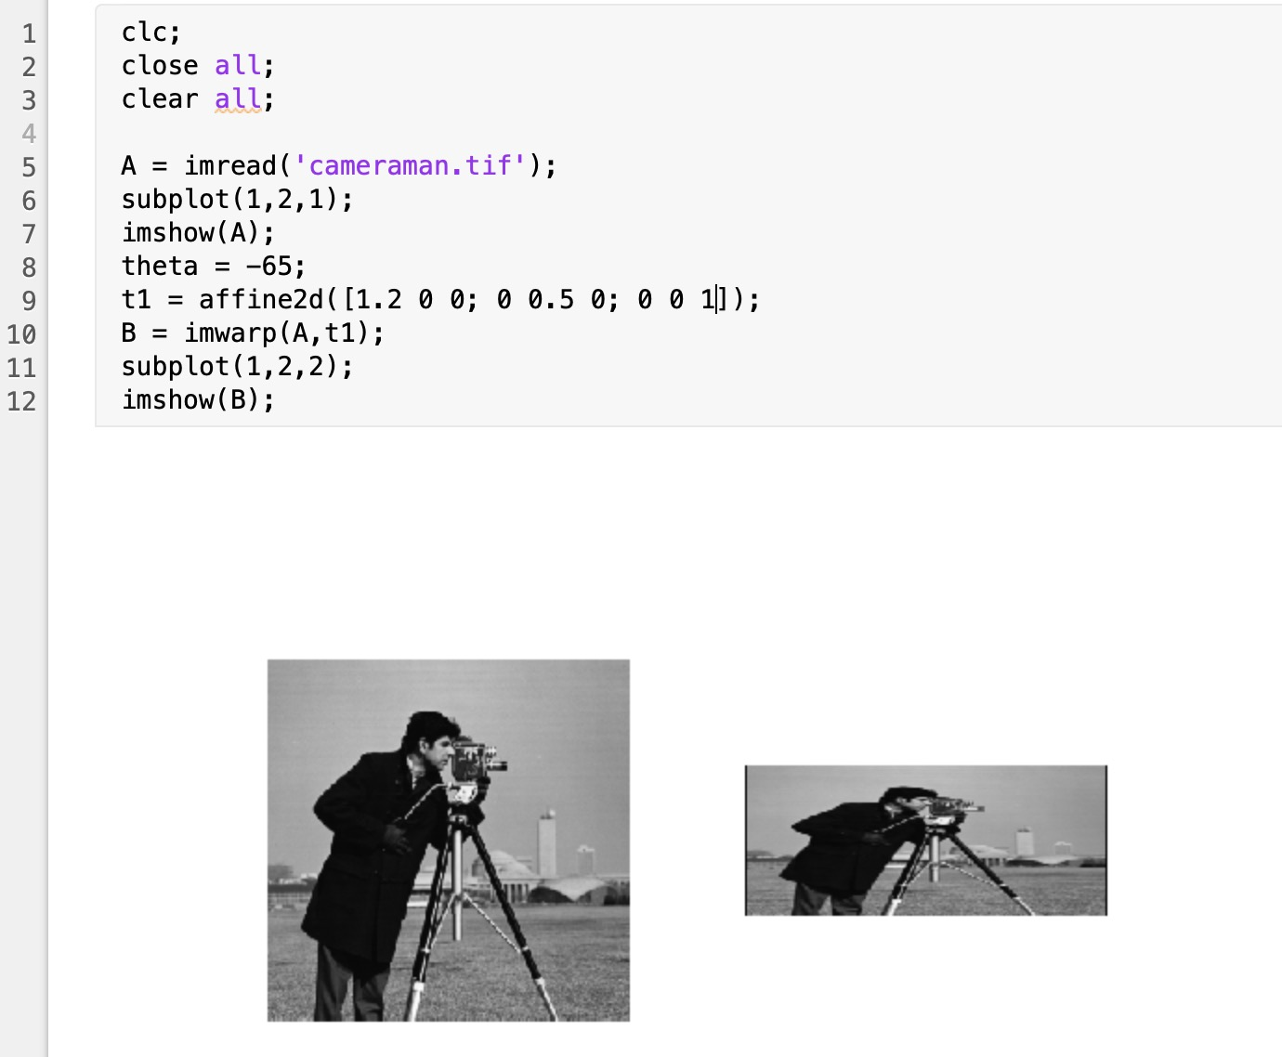

**PRACTICAL – 4**

**AIM:** Write a MATLAB Scripts for the following Point Processing Operations

* **4.1 IMAGE NEGATIVE**

**PROGRAM**

**clc;**

**close all;**

**a=imread('bird.jpg');**

**b=imcomplement(a);**

**subplot(2,2,1),imshow(a),title('Original Image');**

**subplot(2,2,2),imshow(b),title('Negative Image');**

**printf("\n\nID - 18DCS007\nNAME - RUDRA BARAD\n\n")**

**printf('IMAGE NEGATIVE')**

**OUTPUT**

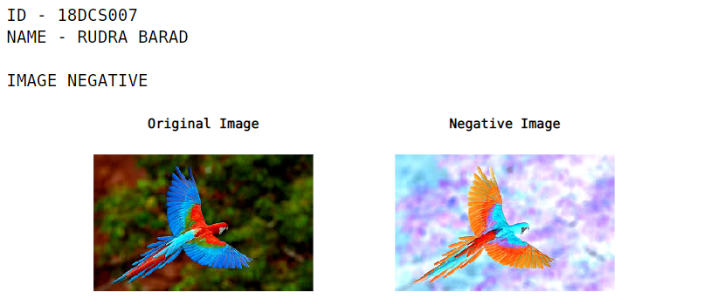

* **4.2 IMAGE THRESHOLDING**

**PROGRAM**

**clc;**

**close all;**

**x=imread('target.jpg');**

**subplot(1,3,1),imshow(x),title('Original Image');**

**x=rgb2gray(x);**

**subplot(1,3,2),imshow(x),title('RGB TO GRAY');**

**x=double(x);**

**tot=0;**

**[rows,cols]=size(x);**

**y=zeros(rows,cols);**

**for i=1:rows**

**for j=1:cols**

**tot=tot+x(i,j);**

**end**

**end**

**thr=tot/(rows*cols);**

**for i=1:rows**

**for j=1:cols**

**if x(i,j)>thr**

**x(i,j)=0;**

**else**

**x(i,j)=1;**

**end**

**end**

**end**

**subplot(1,3,3),imshow(x),title('Threshold Image');**

**printf("\n\nID - 18DCS007\nNAME - RUDRA BARAD\n\n")**

**printf('IMAGE THRESHOLDING')**

**OUTPUT**

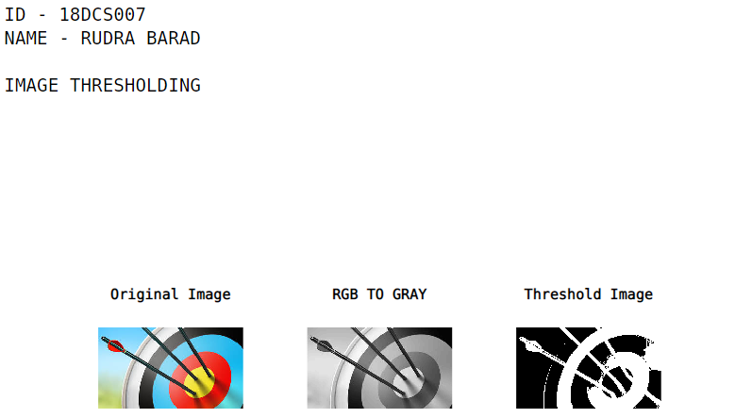

* **4.3 IMAGE BRIGHTNESS & CONTRAST MODIFICATION**

**PROGRAM**

**clc;**

**close all;**

**I = imread('target.jpg');**

**J=I+100;**

**K=I-100;**

**subplot(2,2,1),imshow(I),title('Original Image');**

**subplot(2,2,2),imshow(J),title('Brighter Image');**

**subplot(2,2,3),imshow(K),title('Darken Image');**

**printf("\n\nID - 18DCS007\nNAME - RUDRA BARAD\n\n")**

**printf('IMAGE BRIGHTNESS & DARKNESS')**

**OUTPUT**

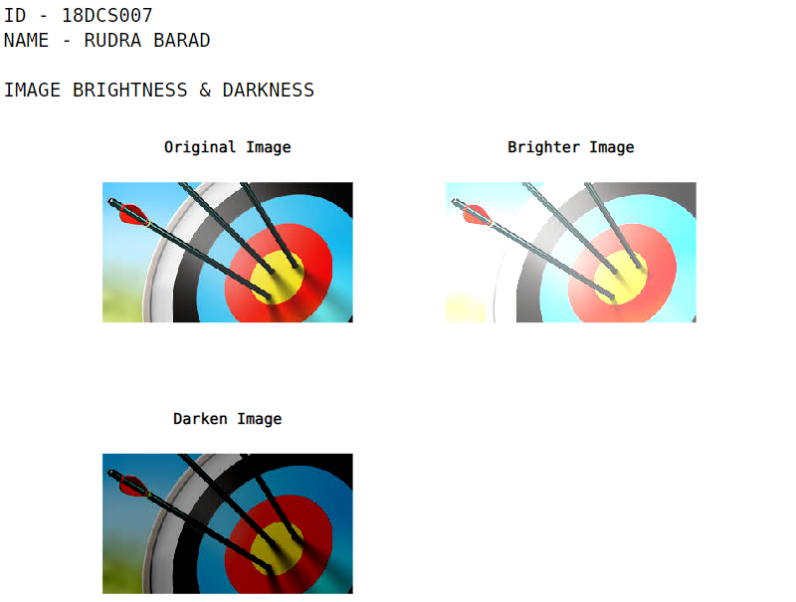

**PROGRAM**

**clc;**

**close all;**

**x = rgb2gray(imread('target.jpg'));**

**a = imadjust(x);**

**b = histeq(x);**

**subplot(2,2,1),imshow(x), title('original image');**

**subplot(2,2,2),imshow(a), title('Image using imadjust');**

**subplot(2,2,3),imshow(b), title('Image using histeq( )');**

**subplot(2,2,4),imshow(b), title('Image using histeq( )');**

**printf("\n\nID - 18DCS007\nNAME - RUDRA BARAD\n\n")**

**printf('IMAGE CONTRAST')**

**OUTPUT**

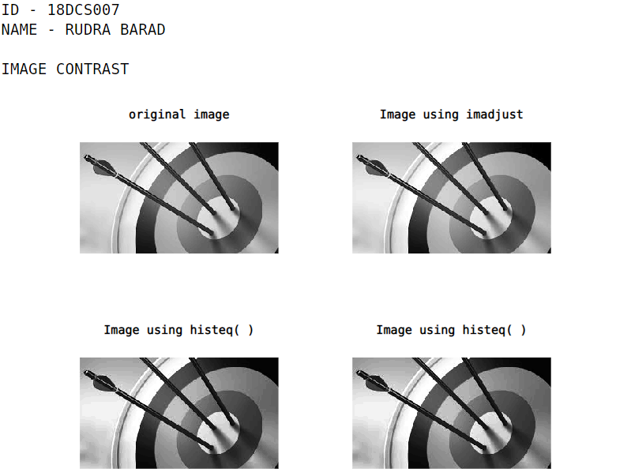

* **4.4 LOG TRANSFORMATION**

**PROGRAM**

**clc;**

**close all;**

**a = input('enter constant value a: ');**

**x=rgb2gray(imread('target.jpg'));**

**x=im2double(x);**

**o1=2*log(1+x);**

**o2=0.5*log(1+x);**

**o3 = a*log(1+x);**

**subplot(2,2,1),imshow(x), title('original image');**

**subplot(2,2,2),imshow(o1), title('output scaling factor 2');**

**subplot(2,2,3),imshow(o2), title('output scaling factor 0.5');**

**subplot(2,2,4),imshow(o3), title('output scaling factor a');**

**printf("\n\nID - 18DCS007\nNAME - RUDRA BARAD\n\n")**

**printf('LOG TRANSFORMATION')**

**OUTPUT**

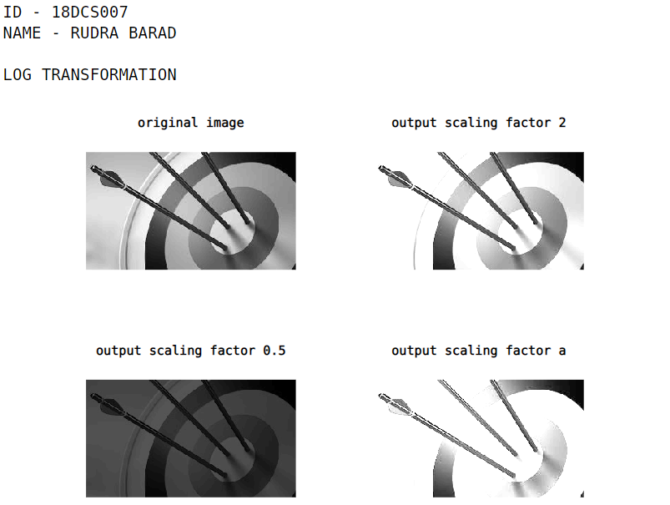

* **4.5 POWER LAW TRANFORMATION**

**PROGRAM**

**clc;**

**clear all;**

**close all;**

**x=rgb2gray(imread('target.jpg'));**

**x=im2double(x);**

**[rows,cols]=size(x);**

**c=2;**

**g = [0.5 0.9 1 3 7];**

**for k = 1:length(g)**

**for i = 1:rows**

**for j = 1:cols**

**y(i,j) = c*x(i,j)^g(k);**

**end**

**end**

**subplot(3,3,k);**

**imshow(y);**

**xlabel(['Gamma = ',num2str(g(k))]);**

**end**

**printf("\n\nID - 18DCS007\nNAME - RUDRA BARAD\n\n")**

**printf('POWER LAW TRANFORMATION')**

**OUTPUT**

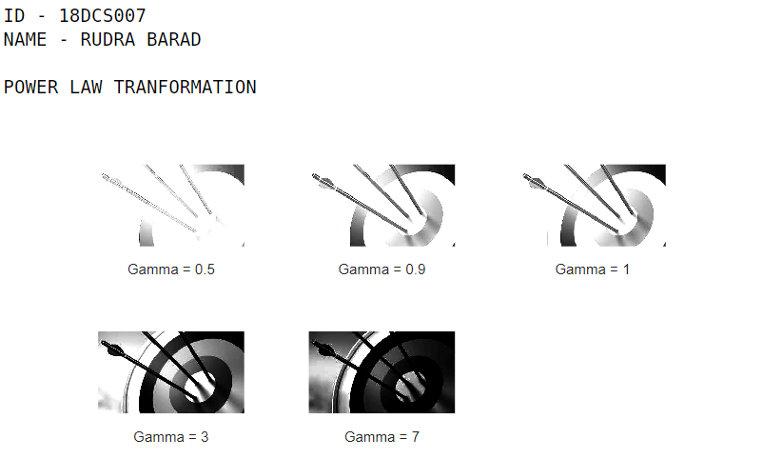

* **4.6 CONTRAST SWITCHING**

**PROGRAM**

**clc;**

**close all;**

**x=imread('target.jpg');**

**i=x(:,:,1);**

**rtemp = min(i);**

**rmin = min (rtemp);**

**rtemp1= max(i);**

**rmax = max(rtemp1);**

**m =255/(rmax-rmin);**

**c= 255 -m*rmax;**

**j = m*i+c;**

**k= imadjust(j);**

**subplot(1,3,1),imshow(i);**

**subplot(1,3,2),imshow(j);**

**subplot(1,3,3),imshow(k);**

**printf("\n\nID - 18DCS007\nNAME - RUDRA BARAD\n\n")**

**printf('CONTRAST STRETCHING')**

**OUTPUT**

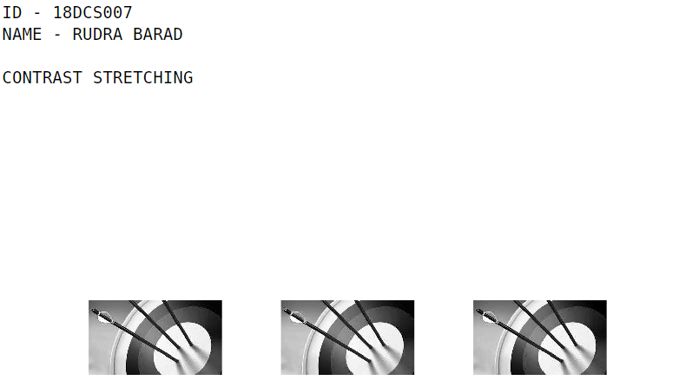



* **4.7 INTENSITY SLICING & BIT PLANE SLICING**

**PROGRAM**

**clc;**

**clear all;**

**printf("\n\nID - 18DCS007\nNAME - RUDRA BARAD\n\n")**

**printf('INTENSITY SLICING')**

**itemp=rgb2gray(imread('target.jpg'));**

**image=itemp(:,:,1);**

**rmin=100;**

**rmax=180;**

**[r,c]=size(image);**

**s=zeros(r,c);**

**for i=1:r**

**for j=1:c**

**if(rmin<image(i,j)&&image(i,j)<rmax)**

**s(i,j)=250;**

**else**

**s(i,j)=image(i,j);**

**end**

**end**

**end**

**figure,imshow(uint8(image))**

**figure,imshow(uint8(s))**

**OUTPUT**

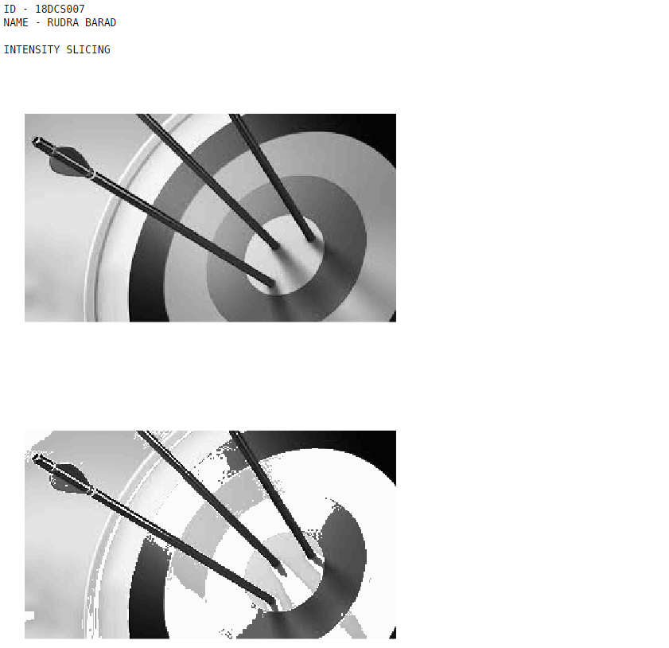

**PROGRAM**

**clc;**

**clear all;**

**close all;**

**it = rgb2gray(imread('target.jpg'));**

**itemp = it(:,:,1);**

**[r,c] = size(itemp);**

**s = zeros(r,c,8);**

**for k = 1:8**

**for i = 1:r**

**for j = 1:c**

**s(i,j,k) = bitget(itemp(i,j), k);**

**end**

**end**

**end**

**figure, imshow(uint8(itemp)); title('original image');**

**figure;**

**subplot(3,3,1); imshow(s(:, :, 8)); title('8th (MSB) Plane');**

**subplot(3,3,2); imshow(s(:, :, 7)); title('7th Plane');**

**subplot(3,3,3); imshow(s(:, :, 6)); title('6th (MSB) Plane');**

**subplot(3,3,4); imshow(s(:, :, 5)); title('5th Plane');**

**subplot(3,3,5); imshow(s(:, :, 4)); title('4th Plane');**

**subplot(3,3,6); imshow(s(:, :, 3)); title('3rd Plane');**

**subplot(3,3,7); imshow(s(:, :, 2)); title('2nd Plane');**

**subplot(3,3,8); imshow(s(:, :, 1)); title('1st (LSB) Plane');**

**OUTPUT**

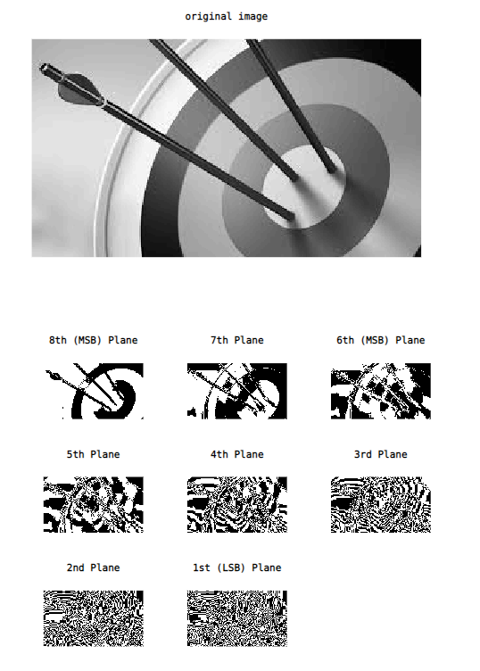

**PRACTICAL – 6**

**AIM:** Write a MATLAB Script for Following Neighbourhood Operations.

* **6.1 LINEAR FILTERING**

**PROGRAM**

**clc;**

**close all;**

**clear all;**

**I = rgb2gray(imread('target.jpg'));**

**I = im2double(I);**

**subplot(1,3,1); imshow(I); title('ORIGINAL');**

**[r c] = size(I);**

**L = zeros(r,c);**

**U = zeros(r,c);**

**for i=2 : r-1**

**for j=2 : c-1**

**M = I(i-1:i+1,j-1:j+1);**

**Min = min(M(:));**

**Max = max(M(:));**

**L(i,j) = Min;**

**U(i,j) = Max;**

**end**

**end**

**subplot(1,3,2); imshow(L); title('MINIMUM');**

**subplot(1,3,3); imshow(U); title('MAXIMUM');**

**printf("\n\nID - 18DCS007\nNAME - RUDRA BARAD\n\n")**

**OUTPUT**

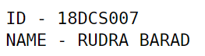

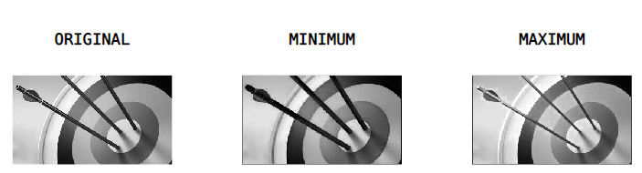

**PROGRAM**

**clc;**

**close all;**

**clear all;**

**img = rgb2gray(imread('target.jpg'));**

**img = imnoise(img,'salt & pepper',0.02);**

**subplot(1,2,1);**

**imshow(img);**

**img = medfilt2(img);**

**subplot(1,2,2);**

**imshow(img);**

**printf("\n\nID - 18DCS007\nNAME - RUDRA BARAD\n\n")**

**OUTPUT**

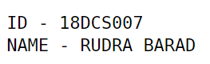

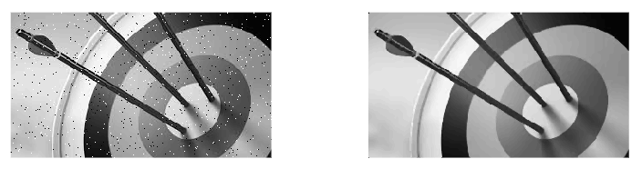

**PROGRAM**

**clc;**

**close all;**

**clear all;**

**I = rgb2gray(imread('target.jpg'));**

**I = im2double(I);**

**subplot(2,2,1), imshow(I), title('ORIGINAL IMAGE');**

**I = imnoise(I,'salt & pepper',0.02);**

**subplot(2,2,2), imshow(I), title('SALT & PEPPER');**

**for i=2:size(I,1)-1**

**for j=2:size(I,2)-1**

**Med(1) = I(i-1,j-1);**

**Med(2) = I(i-1,j);**

**Med(3) = I(i-1,j+1);**

**Med(4) = I(i+1,j-1);**

**Med(5) = I(i+1,j);**

**Med(6) = I(i+1,j+1);**

**Med(7) = I(i,j-1);**

**Med(8) = I(i,j+1);**

**Med(9) = I(i,j);**

**I(i,j) = median(Med);**

**end**

**end**

**subplot(2,2,3), imshow(I), title('MEDIAN FILTER');**

**printf("\n\nID - 18DCS007\nNAME - RUDRA BARAD\n\n")**

**OUTPUT**

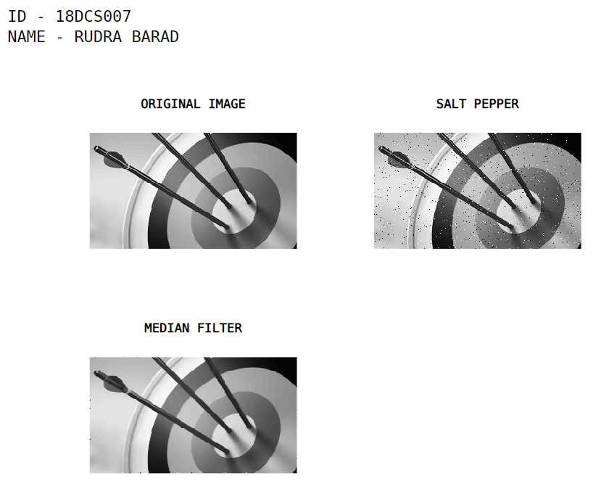

* **6.2 NON-LINEAR FILTERING**

**PROGRAM**

**clc;**

**clear all;**

**close all;**

**a=imread('target.jpg');**

**[r,c]=size(a);**

**a=im2double(a);**

**fil=[0 1 0;1 -4 1;0 -1 0];**

**res=a;**

**for i=2:r-1**

**for j=2:c-1**

**sum=0;**

**row=0;**

**col=0;**

**for k=i-1:i+1**

**row=row+1;**

**col=1;**

**for l=j-1:j+1**

**sum=sum+a(k,l)*fil(row,col);**

**col=col+1;**

**end**

**end**

**res(i,j)=sum;**

**end**

**end**

**imshow(res);**

**printf("\n\nID - 18DCS007\nNAME - RUDRA BARAD\n\n")**

**OUTPUT**

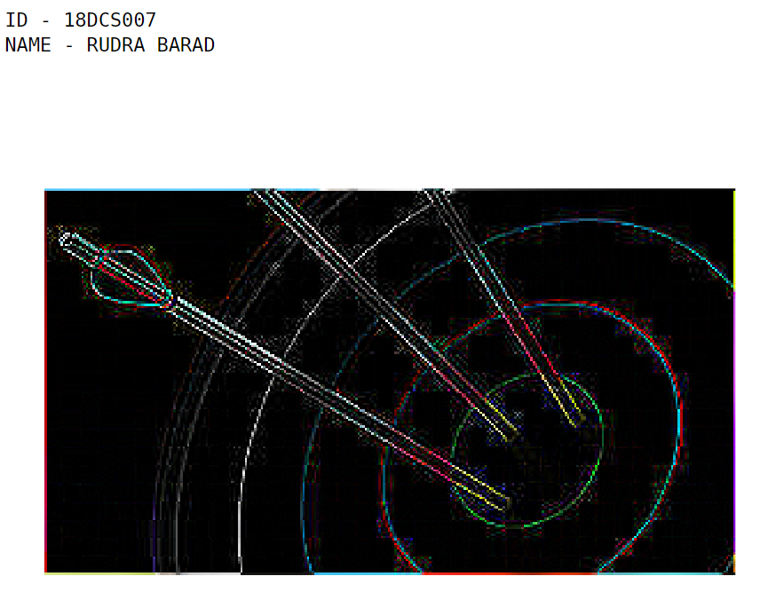

**PROGRAM**

**clc;**

**clear all;**

**close all;**

**a=imread('target.jpg');**

**[r,c]=size(a);**

**a=im2double(a);**

**fil=[0 -1 0;-1 4 -1;0 -1 0];**

**res=a;**

**for i=2:r-1**

**for j=2:c-1**

**sum=0;**

**row=0;**

**col=0;**

**for k=i-1:i+1**

**row=row+1;**

**col=1;**

**for l=j-1:j+1**

**sum=sum+a(k,l)*fil(row,col);**

**col=col+1;**

**end**

**end**

**res(i,j)=sum;**

**end**

**end**

**imshow(res);**

**printf("\n\nID - 18DCS007\nNAME - RUDRA BARAD\n\n")**

**OUTPUT**

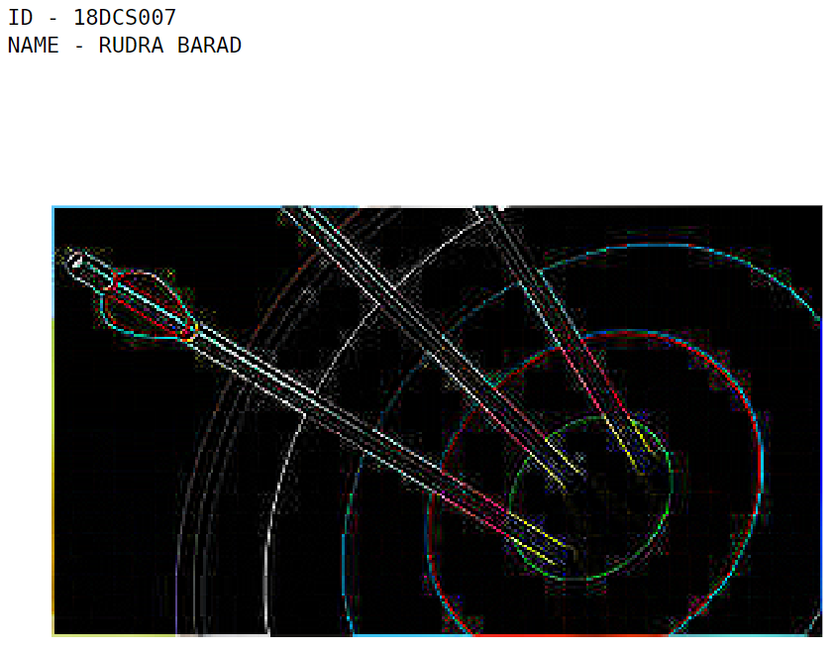

**PROGRAM**

**clc;**

**clear all;**

**close all;**

**a=imread('target.jpg');**

**[r,c]=size(a);**

**a=im2double(a);**

**fil=[1 1 1;1 -8 1;1 1 1];**

**res=a;**

**for i=2:r-1**

**for j=2:c-1**

**sum=0;**

**row=0;**

**col=0;**

**for k=i-1:i+1**

**row=row+1;**

**col=1;**

**for l=j-1:j+1**

**sum=sum+a(k,l)*fil(row,col);**

**col=col+1;**

**end**

**end**

**res(i,j)=sum;**

**end**

**end**

**imshow(res);**

**printf("\n\nID - 18DCS007\nNAME - RUDRA BARAD\n\n")**

**OUTPUT**

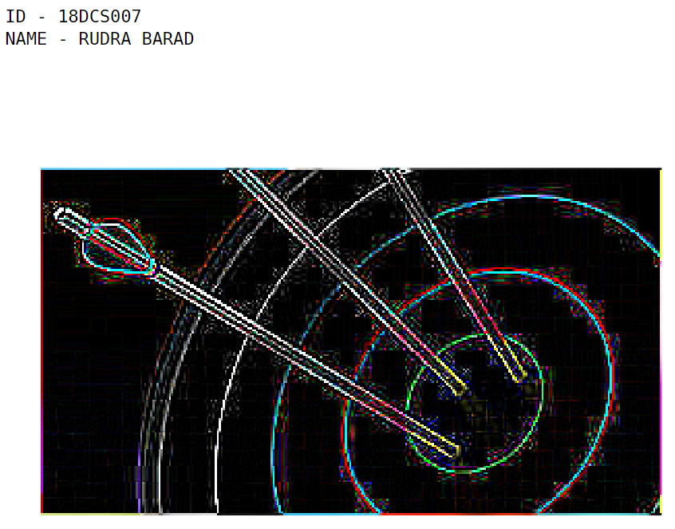

**PROGRAM**

**clc;**

**clear all;**

**close all;**

**a=imread('target.jpg');**

**[r,c]=size(a);**

**a=im2double(a);**

**fil=[-1 -1 -1;-1 -8 -1;-1 -1 -1];**

**res=a;**

**for i=2:r-1**

**for j=2:c-1**

**sum=0;**

**row=0;**

**col=0;**

**for k=i-1:i+1**

**row=row+1;**

**col=1;**

**for l=j-1:j+1**

**sum=sum+a(k,l)*fil(row,col);**

**col=col+1;**

**end**

**end**

**res(i,j)=sum;**

**end**

**end**

**imshow(res);**

**printf("\n\nID - 18DCS007\nNAME - RUDRA BARAD\n\n")**

**OUTPUT**

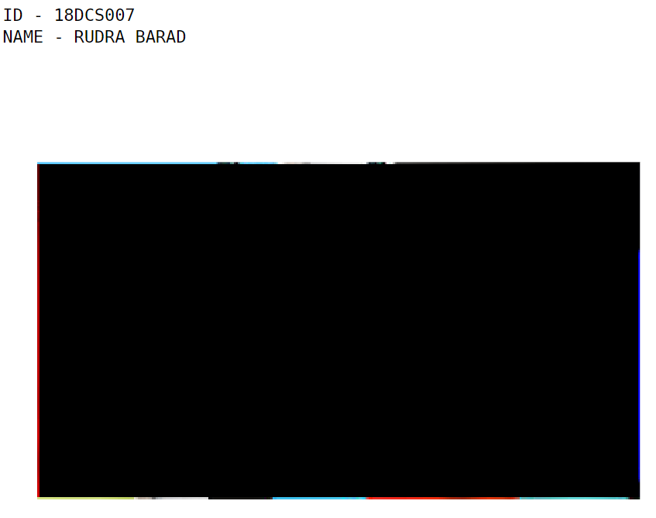

**PRACTICAL – 7**

**AIM:** Write a MATLAB Script for Frequency Domain Filters.

**PROGRAM**

**clc;**

**close all;**

**clear all;**

**I = imread("bird.jpg");**

**N = input("Enter dimension of mask : ");**

**LPF = 1/N^2 * ones(N,N);**

**HPF = -1/N^2 * ones(N,N);**

**n = floor(N/2);**

**HPF(n+1,n+1) = N^2-1;**

**low_pass = I;**

**high_pass = I;**

**for i = 1+n:size(I,1)-n**

**for j = 1+n:size(I,2)-n**

**M = I(i-n:i+n,j-n:j+n);**

**low_pass(i,j) = sum(sum(M.*LPF));**

**high_pass(i,j) = sum(sum(M.*HPF));**

**end**

**end**

**subplot(1,3,1);**

**imshow(I);**

**title("Original");**

**subplot(1,3,2);**

**imshow(low_pass);**

**title("Low pass filter");**

**subplot(1,3,3);**

**imshow(high_pass);**

**title("High pass filter");**

**printf("\n\nID - 18DCS007\nNAME - RUDRA BARAD\n\n")**

**OUTPUT**

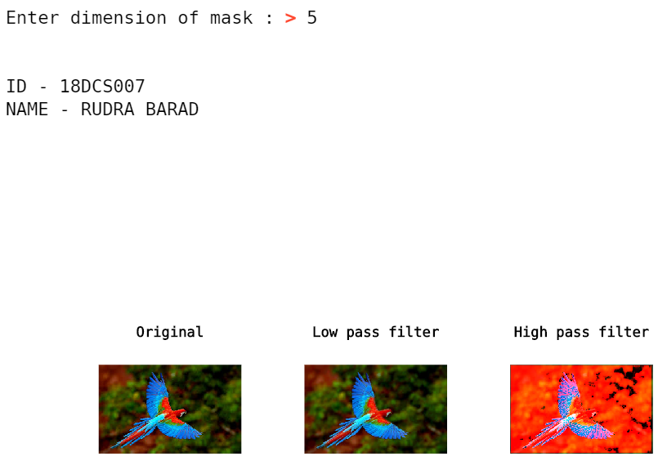

**PROGRAM**

**I = double(im2bw(imread("cameraman.tif")));**

**H = zeros(size(I));**

**subplot(1,3,1);**

**imshow(I);**

**title("Original");**

**I1 = fft2(I);**

**subplot(1,3,2);**

**imshow(log(abs(I1)), []);**

**title("Frequency domain");**

**I2 = fftshift(I1);**

**subplot(1,3,3);**

**imshow(log(abs(I2)), []);**

**title("Frequency shift");**

**rc = size(I,1)/2;**

**cc = size(I,2)/2;**

**H(rc-40:rc+40, cc-40:cc-30) = 255;**

**H(rc-40:rc+40, cc+30:cc+40) = 255;**

**H(rc-40:rc-30, cc-40:cc+40) = 255;**

**H(rc+30:rc+40, cc-40:cc+40) = 255;**

**I3 = I2.*H;**

**figure,**

**subplot(1,2,1);**

**imshow(log(abs(I3)), []);**

**title("Bandpass freq");**

**subplot(1,2,2);**

**imshow(real(ifft2(fftshift(I3))));**

**title("Bandpass Spetial");**

**H = 255 - H;**

**I4 = I2.*H;**

**figure,**

**subplot(1,2,1);**

**imshow(log(abs(I4)), []);**

**title("Bandreject freq");**

**subplot(1,2,2);**

**imshow(uint8(real(ifft2(fftshift(I4)))));**

**title("Bandreject Spetial");**

**OUTPUT**

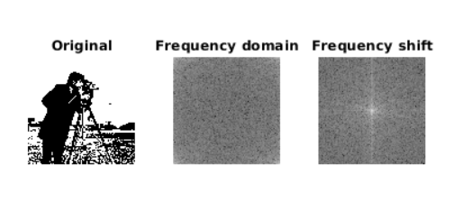



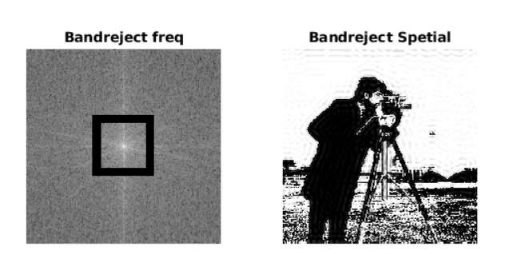

**PRACTICAL – 8**

**AIM:** Write a MATLAB Script for Fourier Transform

**PROGRAM**

**clc;**

**close all;**

**clear all;**

**I = zeros(30,30);**

**I(5:24, 13:17) = 1;**

**subplot(2,2,1);**

**imshow(I);**

**title("Original");**

**F = log(abs(fft2(I)));**

**subplot(2,2,2);**

**imshow(F);**

**title("Frequency domain image");**

**F1 = fft2(I, 256, 256);**

**subplot(2,2,3);**

**imshow(log(abs(F1)),[-1 5]);**

**title("Freq domain image with intensity value -1 to 5");**

**F2 = fftshift(fft2(I, 256, 256));**

**subplot(2,2,4);**

**imshow(log(abs(F2)),[-1 5]);**

**xlabel("Shifted Freq domain image with intensity value -1 to 5");**

**printf("\n\nID - 18DCS007\nNAME - RUDRA BARAD\n\n")**

**OUTPUT**

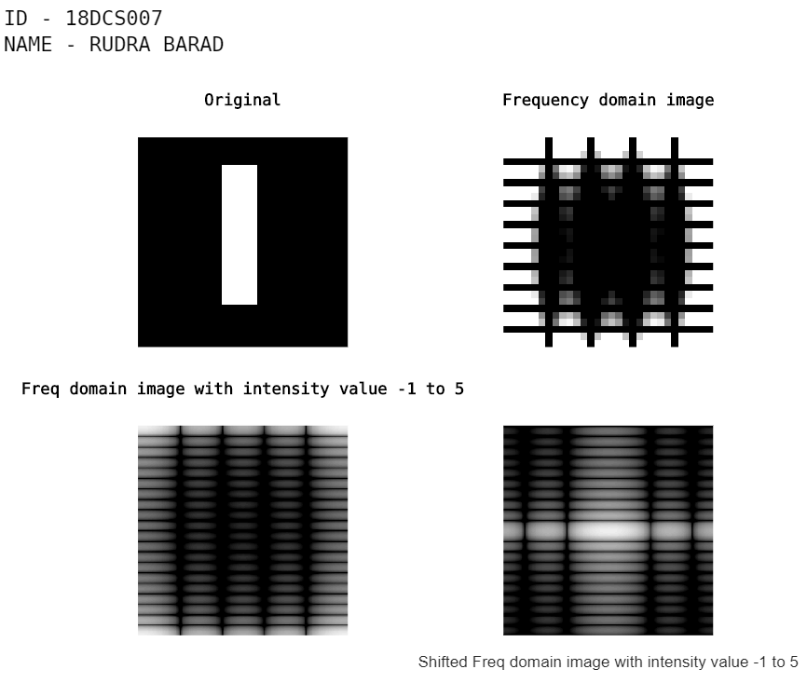

**PRACTICAL – 9**

**AIM:** Write a MATLAB Script for Color Image Processing.

**PROGRAM**

**clear all**

**close all**

**img1 = imread('bird.jpg');**

**figure(1), imshow(img1)**

**size(img1)**

**img1_r = img1( :, :, 1 );**

**img1_g = img1( :, :, 2 );**

**img1_b = img1( :, :, 3 );**

**figure(2), subplot(2, 2, 1), imshow(img1), title('Original')**

**subplot(2, 2, 2), imshow(img1_r), title('Red'), colorbar**

**subplot(2, 2, 3), imshow(img1_g), title('Green'), colorbar**

**subplot(2, 2, 4), imshow(img1_b), title('Blue'), colorbar**

**figure(3), subplot(1, 4, 1), imshow(img1), title('Original')**

**img2 = zeros( size(img1) );**

**img2 = uint8( img2 );**

**img2(:,:,3) = img1_b;**

**subplot(1, 4, 2), imshow(img2), title('1 component: Blue')**

**img2(:,:,1) = img1_r;**

**subplot(1, 4, 3), imshow(img2), title('2 components: R+B')**

**img2(:,:,2) = img1_g;**

**subplot(1, 4, 4), imshow(img2), title('3 components: RGB')**

**printf("\n\nID - 18DCS007\nNAME - RUDRA BARAD\n\n")**

**OUTPUT**



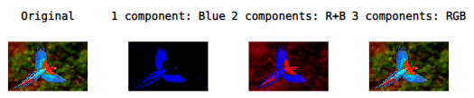



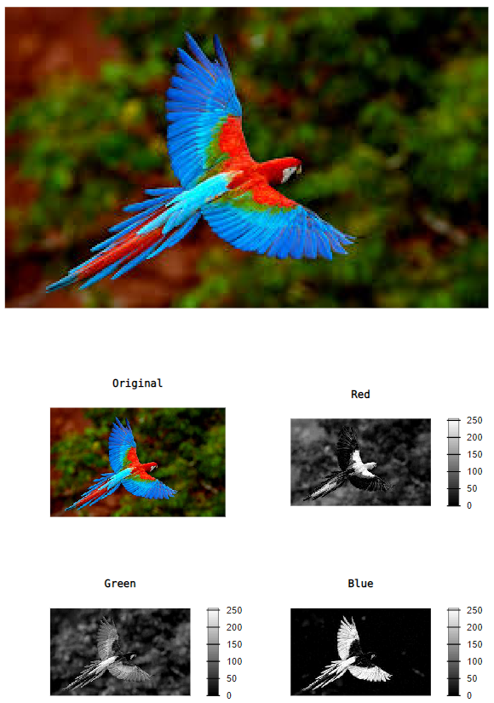

**PRACTICAL – 10**

**AIM:** Write a MATLAB Script for Morphological Operations.

**PROGRAM**

**clear all;**

**close all;**

**testimage = imread('bird.jpg');**

**se = strel('line',11,90);**

**erodedBW = imerode(testimage,se);**

**BW2 = imdilate(testimage,se);**

**afterOpening = imopen(testimage,se);**

**tophatFiltered = imtophat(testimage,se);**

**figure, imshow(tophatFiltered), title('Top Hat Filtered')**

**figure, imshow(afterOpening,[]), title('Opened Image')**

**figure, imshow(testimage), title('Original')**

**figure, imshow(BW2), title('Dilated')**

**figure, imshow(erodedBW), title('Eroded')**

**printf("\n\nID - 18DCS007\nNAME - RUDRA BARAD\n\n")**

**OUTPUT**



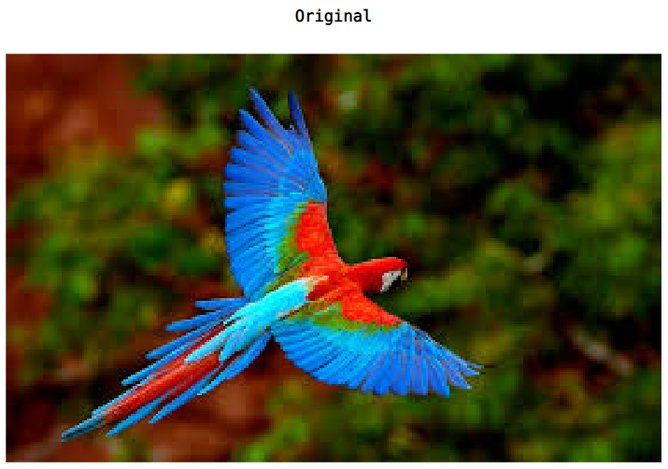

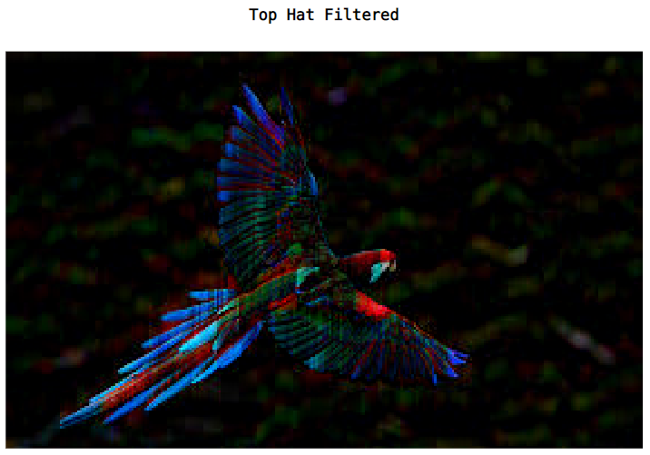

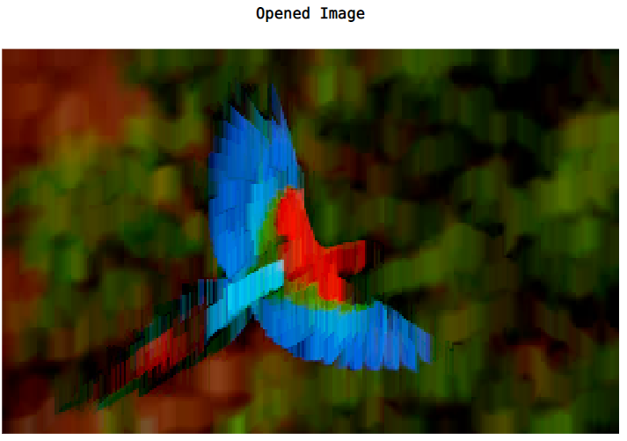

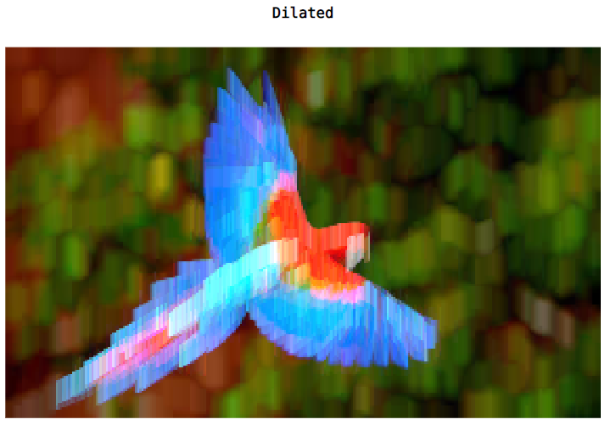

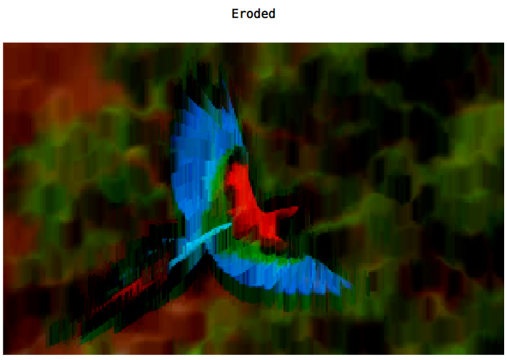

**PRACTICAL – 11**

**AIM:** Write a MATLAB Script for Image Segmentation

**PROGRAM**

**close all;**

**clear all;**

**I = rgb2gray(imread("bird.jpg"));**

**I1 = edge(I, "sobel");**

**I2 = edge(I, "Prewitt");**

**I3 = edge(I, "Canny");**

**I4 = edge(I, "Roberts");**

**subplot(2,3,1);**

**imshow(I);**

**title("Original");**

**subplot(2,3,2);**

**imshow(I1);**

**title("Sobel Edge Detection");**

**subplot(2,3,3);**

**imshow(I2);**

**title("Prewitt Edge Detection");**

**subplot(2,3,4);**

**imshow(I3);**

**title("Canny Edge Detection");**

**subplot(2,3,5);**

**imshow(I4);**

**title("Roberts Edge Detection");**

**printf("\n\nID - 18DCS007\nNAME - RUDRA BARAD\n\n")**

**OUTPUT**



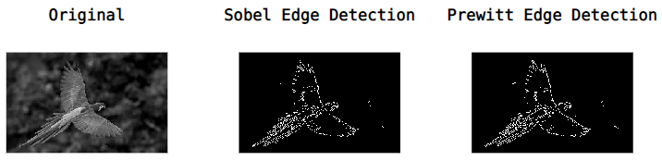

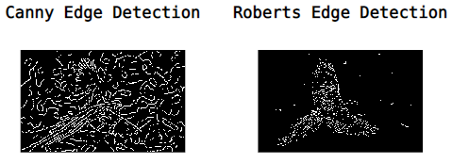

**PRACTICAL – 12**

**AIM:** Demonstration of Open CV

**PROGRAM**

**import cv2**

**import numpy as np**

**img = cv2.imread("bird.jpg")**

**#image display**

**cv2.imshow('Original Image', img)**

**cv2.waitKey(0)**

**#image rotate**

**height, width = img.shape[0:2]**

**img.shape[0:2]**

**rotationMatrix = cv2.getRotationMatrix2D((width / 2, height / 2), 90, .5)**

**rotatedImage = cv2.warpAffine(img, rotationMatrix, (width, height))**

**cv2.imshow('Rotated Image', rotatedImage)**

**cv2.waitKey(0)**

**#image resize**

**newImg = cv2.resize(img, (0, 0), fx=0.80, fy=1.20)**

**cv2.imshow('Resized Image', newImg)**

**cv2.waitKey(0)**

**#Crop image**

**startRow = int(height * .20)**

**startCol = int(width * .15)**

**endRow = int(height * .85)**

**endCol = int(width * .85)**

**croppedImage = img[startRow:endRow, startCol:endCol]**

**cv2.imshow('Cropped Image', croppedImage)**

**cv2.waitKey(0)**

**#complement**

**ci = 255 - img**

**cv2.imshow('Complemented image', ci)**

**#Grayscale image**

**gray_img = cv2.cvtColor(img, cv2.COLOR_BGR2GRAY)**

**cv2.imshow("Gray Scale Image", gray_img)**

**cv2.waitKey(0)**

**#hsvimage**

**hsvImage = cv2.cvtColor(img, cv2.COLOR_BGR2HSV)**

**cv2.imshow('HSV_Image', hsvImage)**

**cv2.waitKey(0)**

**#Gaussian Blur**

**blur_image = cv2.GaussianBlur(img, (7, 7), 0)**

**cv2.imshow('Blur Image', blur_image)**

**cv2.waitKey(0)**

**#Wrapborder**

**wrap = cv2.copyMakeBorder(img, 10, 10, 10, 10, cv2.BORDER_WRAP)**

**cv2.imshow('wrap_image', wrap)**

**cv2.waitKey(0)**

**#edge detection**

**edge_img = cv2.Canny(img, 150, 200)**

**cv2.imshow("Detected Edges", edge_img)**

**cv2.waitKey(0)**

**OUTPUT**

